CLASS-VIII

Chemical elements constitute all of the baryonic (basic) matter of the universe. In total, 118 elements have been identified. The first 94 occur naturally on Earth, and the remaining 24 are synthetic elements produced in nuclear reactions.
Out of 118 elements
92 are Metals
20 are Non-metals
06 are Metalloids
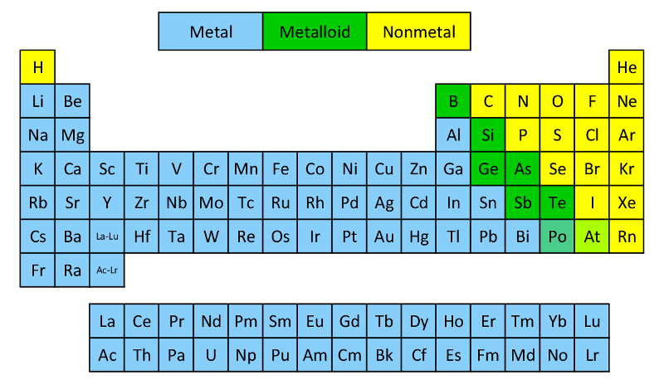

There are about 118 elements. All these elements can be classified into two major groups metal and non metals.
All metals show certain common properties. So , do all non metals. The properties of metals are different from the properties of non metals We will study the occurrence, physical properties, chemical properties and uses of metals and non metals

Some common metals and non-metals
Metals: Sodium (Na), Aluminium Al), Potassium (K), Calcium (Ca), Magnesium(Mg), Copper(Cu), Gold (Au), Silver (Ag), Iron (Fe)

Non-metalOxygen (O), Carbon (C), Sulphur (S), Hydrogen (H), Nitrogen (N), Chlorine (Cl), Phosphorus (p), Helium (He), Iodine (I)

Metals differ in their chemical reactivity's. Some metals are very reactive while others are less reactive
Metals are electropositive elements i.e. they can lose electrons to form positively charged ions called cations.
Metals differ in their chemical reactivity's. Some metals are very reactive while others are less reactive
Occurance
We get metals mainly from the earth’s crust. Metals are also present in the sea and oceans. Aluminium is the most abundant metal in the earth’s crust followed by iron.
Reactive metals like sodium, calcium zinc aluminium and iron occur in combined states as compounds. These compounds of metals which occur naturally are called minerals. They also contain earthy impurities, these earthy impurities are called gangue.

