Light: reflection and refraction
Class-X Science
Light: Light is a form of energy, which when fall on any object it and get reflected back and received by our eyes, which enable us to see things.
Reflection of light:
Reflection of light is the phenomenon of bouncing back of light in the same medium on striking the surface of any object. There are two types of reflection
- Regular reflection or Specular reflection.
- Irregular reflection or Diffuse reflection
Regular reflection: When the reflecting surface is smooth and well polished, the parallel rays falling on it are reflected parallel to one another, the reflected light goes in one particular direction. This is called regular reflection or specular reflection.
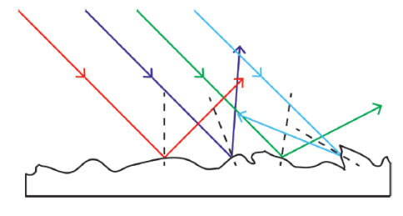
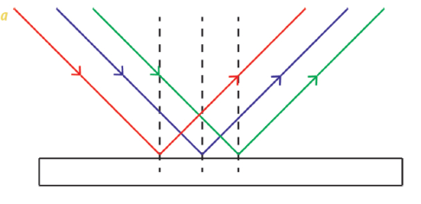
Irregular reflection: When the reflecting surface is rough, the parallel rays falling on it reflected in different direction. Such reflection is known as diffused reflection or irregular reflection

Irregular reflection
Regular reflection
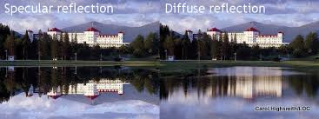

Laws of reflection of light:
According to the laws of reflection of light.
- The angle of incidence is equal to the angle of reflection.
- The incident ray, the normal to the mirror at the point of incidence and the reflected ray, all lie in the same plane.
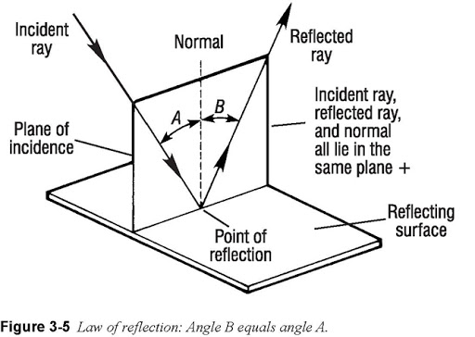
The laws of reflection are applicable to all types of reflection surface including spherical surface.
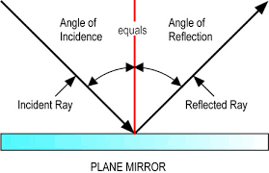

Normal

